Mechanic-Ko

An Emergency Motorist Assistance Web-Application

A Project Study Presented to

the Faculty of the School of Information Technology University of Baguio

In Partial Fulfillment

of the Requirements of the Degree Bachelor of Science in Information Technology

Prepared By: Nikki Joy B. Bang-i

Nap D. Bie

Beverly A. De Vera Mary Hazel N. Garcia

Erna-kristi N. Martinez

March 2018

#### APPROVAL SHEET

This project study entitled **MECHANIC-KO: An Emergency Motorist Assistance Web-Application** prepared and submitted by NIKKI JOY B. BANG-I, NAP ERROL D. BIE, BEVERLY MARIELLE JOAN A. DE VERA, MARY HAZEL N. GARCIA in partial

fulfillment of the requirements for the degree of **BACHELOR**

**OF SCIENCE IN INFORMATION TECHNOLOGY**, has been examined and is recommended for acceptance and approval for oral examination.

#### Erna-Kristi N. Martinez, MIT

Technical Adviser/Class Adviser

#### PANEL OF EXAMINERS

**Aline Teresa L. Mendoza, MIT**

Member

#### Hydi D. Toyeng

Member

#### Ellen M. Halover, MCS, PhD

Member

ACCEPTED AND APPROVED in partial fulfillment of the requirements for the degree of **BACHELOR OF SCIENCE IN INFORMATION TECHNOLOGY.**

#### Engr. Elisabeth D. Calub, MSIT

Dean

#### ABSTRACT

Many motorists have experienced having a car breakdown, at the least expected time and worst, in the middle of the road. As a result, motorists are having difficulties in finding mechanics or nearby auto-repair shops that they tend to wait for help causing them to be late for work, school and others.

Mechanic-Ko: An Emergency Motorists Assistance App, a mobile-web application, addresses this kind of situation. The application aims to provide motorists an easy way to find an available mechanic nearby that can attend to their needs wherever they are, in the soonest possible time. Users such as motorists, mechanics and auto-repair shops can easily access the application since any phone, tablet, laptops or other gadgets with a browser and an internet connection can use Mechanic-Ko.

The development team used the Rational Unified Process as a development methodology to ensure the production of high-quality software that meets the needs of its end- users, within a predictable schedule and budget. This methodology is an iterative incremental model that implements the phases needed to fully support the application. In the execution or end of each phase, a product is created which will be considered a milestone and

an increment of the project. Thus, the phases are repeated until the product development is completed.

In conclusion, the developers have determined the

requirements to design and develop the application. Mechanic-Ko was developed ensuring that the PHP language, HTML, CSS and JavaScript were thoroughly integrated. In addition, the application was designed to allow mechanics and auto-repair shops to register, guided by the terms and conditions which ensures the security and privacy of the users, it also informs the users about the rules and regulations the Mechanic-Ko applies. The terms and conditions should be read by the users to avoid conflict and confusions upon using the application.

Both the mechanic and the motorist has to confirm the

request issued by the motorist to guarantee reliability and security.

#### Acknowledgement

The team would like to express their utmost gratitude and sincerest appreciation to the following who made this study possible:

To Mrs. Erna-kristi N. Martinez, our project study

adviser, for her unending support, guidance and patience all throughout the project development.

To our panelists, Dr. Ellen Halover, Ms. Cherrie Almazan, Ms. Aline Mendoza and Ms. Hydi Toyeng, for sharing their insights and knowledge in improving the project despite our countless mistakes.

To our respondents, the mechanics, motorists and auto-

repair shops in Baguio City and La Trinidad, for their sincere cooperation in answering our queries and testing the system.

To our families and friends, for always believing in

us.

Lastly, the team would like to express their deepest gratitude to the **Lord God Almighty** for his guidance and blessings, this study would not have been possible.

#### N.J.B.B.

**N.E.D.B.**

**B.M.J.A.D.**

**M.H.N.G.**

Table of Contents

TITLE PAGE **………………………………………………………………………………………………………………………** 1 APPROVAL SHEET **……………………………………………………………………………………………………………** 2 Abstract **……………………………………………………………………………………………………………………………** 3

Acknowledgement **…………………………………………………………………………………………………………** 5

Table of Contents **……………………………………………………………………………………………………** 6 List of Tables **……………………………………………………………………………………………………………** 8 List of Figures **…………………………………………………………………………………………………………** 9 CHAPTER

1. INTRODUCTION

Background of the Study **…………………………………………………………** 10 Significance of the Study **……………………………………………………** 16 Objectives of the Study **…………………………………………………………** 18 Scope of the Study **………………………………………………………………………** 19

1. REVIEW OF RELATED LITERATURE/ SYSTEMS **……………………** 20
2. METHODOLOGY

Methodology **…………………………………………………………………………………………** 31 Population and Locale of the Study **……………………………** 34 Data Gathering Techniques **……………………………………………………** 35

1. DISCUSSION OF FINDINGS

Requirements for the Design and Development **……** 37 Design for Mechanic-ko **……………………………………………………………** 44 Testing of the Application **…………………………………………………** 55

1. CONCLUSIONS AND RECOMMENDATIONS

Conclusion **……………………………………………………………………………………………** 58

Recommendations **………………………………………………………………………………** 61

REFERENCES **………………………………………………………………………………………………………………………** 63 APPENDICES

A Statistical Data **……………………………………………………………………………** 67

B Interview Guide **………………………………………………………………………………** 68 C Gantt Chart **…………………………………………………………………………………………** 71 D Statement of Ethics **……………………………………………………………………** 72 E Computation of the Sample Size **………………………………………** 78 F Computation of Interviewed Motorists **………………………** 80 G Statistics and Data Collected **…………………………………………** 81 H Request Letter to Land Transportation Office **…** 91 I Related Literature **………………………………………………………………………** 92 J Beta Test Questionnaire **…………………………………………………………** 93 K Beta Test Results **…………………………………………………………………………** 96 L Computation of Minimum Network Bandwidth **……………**102 M System Requirements Specifications **……………………………**103 N System Profile **…………………………………………………………………………………**213 O System Design Document **……………………………………………………………**221 P Test Cases **……………………………………………………………………………………………**285 Q Requirements Traceability Matrix **…………………………………**294

CURRICULUM VITAE **………………………………………………………………………………………………………**302

List of Tables

Table

1. Minimum Requirements for Client Software **……………** 46
2. Minimum Requirements for Server Software **……………** 47
3. Minimum Requirements for Client Hardware **……………** 48
4. Minimum Requirements for Server Hardware **……………** 49

List of Figures

Figure

1 Project Phases **…………………………………………………………………………………** 31

1. Motorists Use Case Diagram **…………………………………………………** 38
2. Mechanics Use Case Diagram **…………………………………………………** 40
3. Auto-repair Shop Use Case Diagram **………………………………** 42
4. Administrators Use Case Diagram **……………………………………** 43 6 3-Tier Architecture **……………………………………………………………………** 45
5. Hardware View of Mechanic-ko’s Architecture **……** 49
6. Software View of Mechanic-ko’s Architecture **……** 50
7. Mechanicko’s Database Design **……………………………………………** 54

#### CHAPTER 1 INTRODUCTION

Background of the Study

In the society today, having a car or an automobile is already a must. It serves as the most important form of transportation. According to familyeducation.com (2017), the best thing about having a car is the freedom and advantage it gives. Motorists can just pick their destination, hop in the car, and take off. But cars are expensive to buy and maintain. Cars break down occasionally, leaving motorists and passengers sitting by the side of the road in a thunderstorm.

According to Harrington and McConnell (2003), motor

vehicles bring rapid, reliable, and convenient mobility on demand to those lucky enough to have access to them. And increasingly, even in some developing and transitional economies, the lucky ones are not just the elites. The automobile is truly a mass transportation medium, in precisely the same way radio or television is a mass communication medium.

Moreover having a car nowadays is not a problem to environment because according to the American Chemical Society (2017), recycled polycarbonate (PC - are used to

produce a variety of materials that is commonly used for plastic lenses in eye wear, in medical devices, automotive components, protective gear, greenhouses or digital disks and polyurethane (PUR) - is the material choice for a broad range of end-user applications including car parts, coatings, adhesives rollers and tires. Both are ideal for building insulation, refrigerators, cushions and packaging products. Here, the chemical society developed a way to recover PC and PUR from waste car plastics with coconut oil and microwaves. This created a renewable and recycled product that did not degrade.

According to Tan (2014), Baguio City has to cope with

so many problems arising from its status as a highly urbanized city. One of these is traffic-related problems brought about by the increase in the number of pedestrians and vehicles traversing the city’s various road corridors. Traffic congestion, as well as traffic accidents, is an ensuing problem that usually occurs in fast growing cities like Metro Manila and Baguio City due to the constant mobility of people and goods. With the increase of automobile usage each year, an evaluation of this demand is needed in order to balance the capacity of urban road as well as rural road networks (De Guzman & Sigua, 2016).

According to the Texas Transportation Institute (TTI) (2015) at Texas A&M University, a motorist might spend as much as two weeks in the car each year. An official estimates that metropolitan Manila's notorious traffic jams cost the Philippine economy at least 3 billion pesos ($64 million) a day (Philstar, 2015, September 16).

According to tradingeconomics.com (2017), the

approximate number of registered cars in the Philippines is 103,576 monthly. While in 2013, the Land Transportation Office have recorded that 7,690,038 vehicles both public and private are registered (Appendix A). Furthermore, the Philippine Statistics Authority (PSA) and the city of Baguio Office of the City Planning and Development Coordinator states that in the second quarter of 2014, the registered number of motor vehicles is 9,639 and the number of driver’s license issued is 11,137 while in the third quarter of 2014, the registered number of motor vehicles is 10,143 and the number of driver’s license issued is 9,981. Thus, car breakdowns and volume of cars on roads are also increasing.

There are many problems that are encountered in the

roads nowadays, and car breakdown is one of the frequent cases that is faced which results to traffic and other road situations, as well as inconvenience to motorists and

commuters. According to the Philippine Statistics Authority (PSA), there are hundreds of cars that are breaking down on roads daily.

In 2015, the World Health Organization (WHO) reported, that out of 953 reports they had surveyed, 497 were about specific road crash events containing 299 unique road crash events. Furthermore, the organization also stated the common causes of road crashes, which include loss of brakes having 48 incidents, speeding, reckless driving, alcohol, loss of control and also engine trouble. According to Bureau of the Baguio City Police Office (BCPO), they have recorded 168 vehicular accidents for the first three weeks of April in the year of 2016.

According to American Automobile Association (AAA)

(2014), they had responded to more than 29 million calls for roadside assistance in North America, with the majority (17 million) due to battery failure, flat tires and keys locked inside vehicles. Aside from that, according to RAC Patrols in 2006, motorist confusion about the workings of in-car accessories and devices was often responsible for call-outs.

Taking care of car is one way to reduce contributions to traffic jams. Properly maintained cars can help prevent breakdowns on the road. Maintenance includes regular oil

changes, tune ups and tire care. Keeping car in good working order will save time and money and might help people out of dangerous situations.

But despite warnings and campaigns on car functionality awareness, there are still motorists who tend to set aside the importance on how car works. An example stated by Moskvitch (2014), the lack of learning causes motorists to depend solely on technology, which when without technology or electronic guide, are lost and do not know what to do already.

Aside from that, according to ucpbgen.com (2016), regardless of whether having a new or used car, car breakdowns will happen at the worst possible time. And everybody knows there is nothing like having a car break down to ruin a road trip. Although it may not happen everyday, dealing with car troubles is usually a drag for the motorist. Most motorists do not even have the experience or physical strength to deal with common breakdowns which is also pointed out by bbc.com (2014).

Out of 10 motorist interviewed as shown in Appendix F,

7 stated that car breakdown causes traffic. According to Mr. Aguinaldo, a motorist, who experienced causing a traffic congestion because of a car break down in the middle of the road (personal communication, July 1, 2017).

As stated by Mr. Winston, a jeepney driver and a mechanic, who had a car break down on the middle of the road found it difficult to seek for help (personal communication, July 1, 2017). In addition to car breakdowns, Mr. De Leon, a motorist, who had encountered a lot of car breakdowns while travelling in the middle of the road (personal communication, July 1, 2017). According to Mr. Ugay, a private vehicle owner, said that car breakdowns cause traffic, because even if you maintain your car you would not know what will happen (personal communication, July 19, 2017). Thus, car breaking down in the middle of the road may cause a huge traffic congestion and is not only embarrassing but also frightening due to road accidents.

Moreover, motorists cannot just wait for a day to end

and seek immediate assistance for their broken down vehicles. As stated by Mr. Ugay, “when my car broke down

all of a sudden I called my friend and he said that he will be there for about thirty minutes and during that time it was hard for me to wait that long because of the important urgent meeting I must attend to” (personal communication, July 1, 2017).

With the aforementioned car breakdown issues and concerns, the proponents have proposed a system that would help both the motorists and mechanics. The system has been

named Mechanic-ko. Mechanic-ko has been designed to provide motorists, auto-repair shops or even mechanics nearby to fix car problems wherever they are in the soonest possible time.

#### Significance of the Study

According to Mr. Del Mundo, a jeepney driver, who calls a mechanic whenever a car break down happens. The mechanic is either a fellow motorist or a colleague that is an expert on repairing automobiles. Especially when a defect is major, calling a mechanic is a must to repair the damage of the car. The Mechanic-ko application is a way to easily contact mechanics when colleagues are not available (personal communication, July 1, 2017). As stated by Ms. Chan, a private car owner, who said that calling mechanics that are recommended to her goes to their house to repair the car. Ms. Chan also stated that “if this application

will be available it will be convenient to me because I will be able to call a mechanic right away at my home” (personal communication, July 1, 2017).

Through this study, the team have develop a mobile-web application that helped motorists locate auto repair shops or mechanics within the area by knowing the user’s current location or an on-call mechanic that can be contacted easily to go where the user is. Locating the user and

mechanic can happen through the use of GPS or Global Positioning System. GPS is a network of orbiting satellites that send precise details of their position in space back to earth. The signals are obtained by GPS receivers, such as navigation devices and are used to calculate the exact position. The motorist’s current location can be determined through the phone’s GPS or locator. Eligibility and the quality of service of the business and mechanic is assured since the performance rating and other important details of the auto-repair shop can be viewed. According to Mr. De Leon, a private car owner, the application will help in the most urgent and important matters to attend with because the car can get assistance right away (personal communication, July 17, 2017). Thus, it will be less time consuming and no worries upon the delay on the things they need to do.

Similarly, it will help provide more employment opportunities to mechanics. According to Mr. Winston (personal communication, July 1, 2017), having this application is a good thing because it will benefit mechanics through giving more work opportunities. As stated by Mr. Deli, who gets a call whenever a vehicle breaks down in the residence, Scout Barrio, Baguio City. Mr. Deli also added, being part of this application “I will be able to

fix many other cars not just my colleague’s and it will be an opportunity for me to have more clients and is a good thing because it will increase my income”. Mr. Deli also said that it can be an advantage for mechanics to have more customers. “If there is a client that needs a mechanic and he does not have the tools he or she can call us, an on call mechanic to respond to their needs” (personal communication, July 1, 2017). As stated by Ms. Rivera (personal communication, July 10, 2017), having this application can promote auto-repair shop businesses well and be known by those motorists who are not familiar with the auto-repair shops. Therefore, this study have been a way to promote the auto repair shops that are not yet known by the public but gives satisfying repairs to vehicles. Furthermore, while doing the research, the proponents have agreed to apply ethical standards found in Appendix D (Statement of Ethics between researchers and respondents). **Objectives of the Study**

The objective of the study is to develop a mobile-web application that can be used by drivers to locate auto- repair shops or mechanics nearby.

Specifically, it aims to:

1. determine the requirements for the design and development of Mechanic-ko;
2. create an appropriate design for the application, and;
3. build and test the application.

#### Scope of the Study

Mechanic-ko is a mobile-web application that is accessible from any platform. It has a responsive design allowing the web pages to be viewed in response to the size of the screen or web browser of different devices.

This system enables motorists to locate nearby auto- repair shops and on-call mechanics and allows them to search and filter the auto-repair shops and/or on-call mechanics according to distance. Also, notifications have been used, as well as the GPS and phone locator, which have been utilized to determine the current location of the clients, mechanics and auto-repair shops. The clients can also rate and comment to the service, response time, attitude and fee of the mechanic or auto-repair shop.

Mechanic-Ko only covers Baguio City and La Trinidad, Benguet due to time and cost constraints.

#### CHAPTER 2

**REVIEW OF RELATED LITERATURE/ SYSTEMS**

**Related Literature / Systems**

Mechanic-Ko uses the real-time Global Positioning System (GPS) location on phones, tablets or laptops likewise the geolocations for google maps Application Program Interface (API). Geolocation is the identification or estimation of the exact location of a computer, networking device of equipment while Google Maps provide detailed information about geographical regions and sites. These deploys the finding and viewing of the auto-repair shop or mechanic within the area.

Based from interviews conducted with several owners of auto-repair shops in Baguio City and La Trinidad, most of the services offered are: wheel alignment; locksmith services; changing the batteries and oil of the vehicle; repairing the cars’ engine starters, car brakes, car tires, car radiator; transmission and engine replacement; Aside from those, some auto-repair shops also offer towing services where tow car (B. Santiago, personal communication, July 1, 2017).

These services rendered are not only for customers who go to the shops but also for those roadside car breakdowns or even those cars immobilized at home. Car breakdown is

the mechanical failure of a motor vehicle. It is the inability of the parts to perform as it is designed to function.

Similar applications for each mobile phone have been developed to offer emergency roadside assistance. Roadside assistance is something that most motorists wants. There are many applications and systems out there that provide roadside assistance in case of accidents, car brakes stop working or worse, the engine dies. Many car makers have their own roadside assistance apps, as well as some insurance companies.

**Mapfre Road Assist** is a mobile application by MAPFRE

INSULAR Insurance Corporation that offers automatic roadside assistance service on the go with just a few clicks away. It offers a 24/7 emergency roadside assistance even in cases of mechanical or electrical breakdown or the abrupt rise of electric current in the presence of a small increase in electric voltage. Mapfre Road Assist offers services such as towing, tire replacement service, fuel delivery, locksmith service where a person who makes or repairs [locks](https://www.merriam-webster.com/dictionary/locks) and battery boosting (Mapfre, 2016).

Mechanic-Ko has utilized the 24/7 assistance for the customers to view the availability of the auto-repair shops anytime.

**FI Roadside Assistance** is a mobile application that attends to vehicles whether immobilized at home or on the road. If the car experienced a mechanical or electrical breakdown, a recovery vehicle will be sent at the current location from the nearest authorized dealer (India Assistance, 2017). The concept of nearest authorized dealer has been adopted by Mechanic-Ko in order to provide motorists with the available auto-repair shops within the area.

**Carput - Car Breakdown Assist** is a mobile application

that offers a safe, fast and reliable way to get access to proper roadside assistance when needed. Carput connects their customers to their panel of vehicle professionals that provides straightforward and transparent automotive assistance. The Carput App gives their customers an access to petrol delivery, vehicle towing, engine jump start, car battery replacement and flat and/or spare tire replacement (Carput, 2016). Mechanic-Ko utilized the safe, fast and reliable way for drivers to get access to mechanics and the auto-repair shop.

**E.R.A** is a 24-Hour Emergency Roadside Assistance

Program (E.R.A) that provides a quick and reliable help on the road that is exclusive to Ford Customers. E.R.A provides customers a good feature, giving them a card that

entitles them a year of basic services such as vehicle towing, battery jump-starts, fuel delivery and flat tire change. E.R.A offers a 24/7 emergency assistance and emergency vehicles will be dispatched to provide minor on- site repairs (those which are included in the basic services) and/or provide towing services to the nearest Ford dealership. E.R.A. customer service assistants can also provide customers with information on hospitals, transmittal of urgent messages, arrangement of alternative means of transportation, medical evacuation and other related services that can be of help to customers during these times (Geronimo Web Ltd 2010-2017). Mechanic-Ko has been created with the idea of providing necessary information to the clients and/or customers such information as National Certification II passers, passed government requirements, seminars and trainings.

#### State Farm Mutual Automobile Insurance Company

**(SFMAIC)** provides a roadside assistance. Customers who needs the service have to call the emergency number of SFMAIC and a service provider will be dispatched to assist and take care of the emergency road service need. The features of SFMAIC includes towing, locksmith, oil delivery, jumpstart and change tires (State Farm Mutual Automobile Insurance Company, 2017). The application used

the notion to give customers assistance on contact numbers that redirects them directly to the business or to the on- call mechanics.

#### Nationwide Mutual Insurance Company provides

Nationwide Roadside Assistance that provides customers simple and easy ways to get back on the road. The 24-hour emergency roadside program provides towing, a jump start, gas delivery, a flat tire change, even the services of a qualified locksmith. Nationwide Roadside Assistance will confirm the customer’s location and send emergency services. A Roadside Assistance field representative will be dispatched to the user’s location to help (Nationwide Mutual Insurance Company, 2017).

There are related studies that states and shows about

car breakdowns, roadside assistance, the effects to the people and the society, and how mobile-web applications has been useful in quick roadside assistance:

According to WHO (2015), there are 3 broad groups on the causes of road crashes: driver-related, vehicle-related and road-related causes. Driver-related causes are those that have specifically to do with the condition or behavior of the motorist. Vehicle-related causes have to do with the mechanical condition of the vehicle. Road-related causes have to do with external conditions. The Department of

Transportation and Communications (DOTC) reported that in 2013, 79% are driver-related, 11% are vehicle-related and 10% is road-related. And several solutions were laid: stricter public transport franchise regulation, improvement of traffic enforcement, road user education, improvement of road infrastructure, implementation of safety inspections on public transport, improved vehicle maintenance, improvement of mass public transport infrastructure and enforcement of speed limits. Improved vehicle maintenance is included because of the involvement of the automobile and how the automobile works, and thus, might lessen the result of road crashes due to vehicle-related causes.

Based from the interview with one of the mechanics of auto-repair shops, who said that everyday customers have different and unique problems. Thus, services and rates depends on the car model and the degree of the defect or damage of the car. The mechanic also said that it would be great if there would be a system that can provide service to clients and can also provide an opportunity to be known by motorists.

According to the interview with private vehicle

drivers, who said it would be a great help if the application Mechanic-ko would be implemented. Since leaving the cars on the roadside may result to theft or road crash.

Car breakdowns are unforeseen, and it could happen anytime, the application provides a way to help motorists find a mechanic.

Furthermore, a review of American Automobile Association (AAA) in June 2017, that the emergency roadside assistance was helpful and quick. The service was reliable and when was called for assistance, the response was fast.

The application Mechanic-ko have provided a service to find the location of the nearby auto-repair shops and mechanics as well as the user. But for the location feature to work, necessary programs are needed.

**Location Based Services (LBS)** are technologies capable

of providing services personalized to the geographic location of a user based on a given handheld device for a particular purpose predominantly in the domains of emergency and personal safety, navigation, and access to information on the go, which all provide value to the user (Anuar & Gretzel, 2011). A number of LBS applications have been established and made which uses the phone’s GPS coordinates, a cellular network or WiFi connections in order to track one’s position (Toch et al., 2010). According to the 2008 fourth-quarter report from Nielsen Mobile, location-based services account for 58 percent of the total downloaded application revenue for mobile phones

in North America (Rouse, 2009). Similarly, LBS have been used by Mechanic-ko in getting the location of the user as well as tracking the location of a mechanic or auto-repair shop.

Applications that has the Location Based Services

(LBS) feature have already been developed. Zomato and Grab are applications that uses the location based services.

**Zomato** is a website where customers review restaurants

and other food and drink outlets. Zomato members use the site to choose where to eat, often when members are already out. Zomato members simply type in a category of restaurant

(e.g. 'Italian') and the site generates a list of options

nearby using GPS. The concept finding nearby restaurants by typing categories of food has been used by the application Mechanic-Ko wherein motorists were able to find the nearest mechanics or auto-repair shops.

**Grab** allows users to book a taxi using smartphones.

Commuters find cabs and cab drivers find passengers using GPS tracking. The concept of finding the nearby cab drivers has been used by the application Mechanic-Ko for finding the mechanics or auto-repair shops near the location of the user. Similarly, Grab displays the current location of the user and the information about the cab drivers and the travel time to get to the passenger. Mechanic-Ko used the

concepts of Grab wherein the user’s location have been displayed together with the nearby mechanics and auto- repair shops. The mechanics were the one to indicate the travel time. Grab also allows cancellation of booking, the cancellation has been applied in Mechanic-Ko wherein the motorist and mechanic can cancel bookings with limited number of times.

Therefore, according to the World Health Organization (WHO), every year the lives of approximately 1.25 million people are cut short as a result of a road traffic crash. Between 20 and 50 million more people suffer non-fatal injuries, with many incurring a disability as a result of the injury. Road traffic injuries cause considerable economic losses to individuals, families, and to nations as a whole. Economic losses arise from the cost of treatment as well as loss of productivity for the killed or disabled by the injuries, and for family members who need to take time off work or school to care for the injured. Inadequate post-crash care or delays in detecting and providing care for the individuals involved in a road traffic crash increase the severity of injuries. Care of injuries after a crash has occurred is extremely time-sensitive: delays of minutes can make the difference between life and death. (WHO, 2017)

In the same way poorly maintained vehicles cause thousands of wrecks each year. The bill for accidents resulting from unperformed vehicle maintenance tops $2 billion a year, according to a 2004 study by Car Care Council, an advocacy group based in Bethesda, Md. “Even if you are lucky enough to avoid a crash, putting off maintenance is likely to reduce your car’s lifespan” (Burnette, 2014).

Mechanic-ko caters a lot of drivers and motorists, as well as mechanics and auto-repair shops, because according to the Land Transportation Office (LTO), the number of registered cars in Baguio City and La Trinidad for 2016 is 40,576. Aside from that, the Department of Trade and Industry (DTI) also stated that 219 auto repair shops are currently registered in Baguio City and La Trinidad in the year 2016 to 2018. Through the data collected from LTO and DTI, the sample size are computed and used in getting the number of respondents the proponents have interviewed for the application as shown in Appendix E.

The studies and other related literature discussed

have been used by the team as references and basis in developing the application. Mechanic-ko’s features has been closely related with the mobile apps mentioned, the

difference is, Mechanic-Ko runs on the user's mobile, tablet or laptop browser to provide instant accessibility.

#### CHAPTER 3 METHODOLOGY

This chapter discusses the methodology, population and locale of the study as well as data gathering techniques used by the proponents in conducting the study.

#### Rational Unified Process Methodology (RUPM)

The development team used Rational Unified Process as a development methodology to ensure the production of high- quality software that meets the needs of its end-users, within a predictable schedule and budget. (Rational Software, 1998)

The development team implemented the phases of

workflow presented in Figure 1

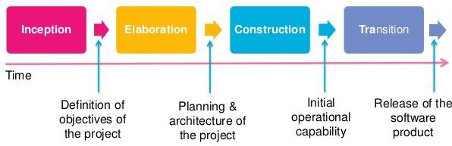

#### Figure 1: Project Phases Inception

In this phase, the study was introduced, some of the related systems and literature are discussed and the

project scope was delimited. Gathering requirements was included in knowing how the application was created. One of the ways done to gather requirements was to interview users composed of mechanics, auto-repair shop owners, and motorists. Moreover, the initial scheduling of activities was created to know how the developers maximized tasks. Thus, the outcomes were the proposal document that includes the project’s core requirements, key features and main constraints and an initial schedule of activities. The scheduling tool used was the gantt chart as shown in Appendix C wherein the list of ongoing and achieved activities are identified. Several defenses were done in this phase for the revisions of the project and the milestone that was created was accepted proposal. **Elaboration**

In this phase, the team analyzed the problem to address the importance of making this application. The developers focused on the design of the application and had established a requirements specification based from the researches and studies gathered. Coding of the prototype was also done in this phase with several revisions and iterations through the defenses that were done. This phase was cyclic because the development and design were continuously adapted and changed according to the

requirements of the stakeholders and users. Thus, the milestones that were created in this phase were the Accepted SRS and Prototype.

#### Construction

In this phase, the prototype for the application and all its features had been thoroughly tested for validations and testing whether the functionalities were working well. The management mindset undergone a transition from the development during inception and elaboration, to the development of deployable products during construction and transition. Gray Box testing was done for validations and test whether the functionalities were working well. The softwares that had been used here were the text-editing softwares such as sublime, notepad++ and atom. The milestone of this phase was a product that underwent several testing iterations with the use of test cases. **Transition**

The purpose of this phase was for the transition of the application to the user community. Defined users such as the mechanics, auto-repair shops and motorists had been part of the beta-testing. Several iterations were created, parts of the design of the application were revised based from requirements that had changed. The milestone for this

phase was a complete functioning system and rolling out the product to the market.

In the execution or end of each phase, a product was

created as shown in Appendix C, which were considered a milestone and an increment of the project. The phases were repeated until the product development is completed. **Population and Locale of the Study**

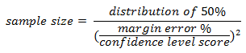The focus of the study were motorists such as taxi drivers, jeepney drivers, private car owners, as well as mechanics and auto-repair shop owners in Baguio City and La Trinidad. The Land Transportation Office provided the number of motor vehicles registered which was 40,587. The sample size and number of interviewees were computed using the formulas:

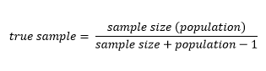

Thus, the number of motorists that was interviewed was 381, while the number of auto-repair shops was 140 and 267 mechanics were interviewed since an auto-repair shop has an average number of 4 mechanics, Baguio City and La Trinidad combined as computed in Appendix E. Municipalities in the

province of Benguet were not included due to the problem on the accessibility to auto-repair shops and mechanics for interviews and observations.

#### Data Gathering Techniques

**Interviews**

The team conducted interviews to obtain or gain awareness from the mechanics, motorists and auto-repair shops on the particular field relating to Mechanic-ko, the team used guide questions(Appendix B) during the interviews to make sure that nothing is left out. The responses were used as guide in satisfying the requirements of the system. Motorists provided insights and opinions about the application interface, while the mechanics and auto-repair shops provided the details and information about the transaction processes and repairs. The number of interviewees served as a basis for the developers to determine how many feedbacks should we get to measure the importance of making this project. In computing for the number of people to interview, we had collected the statistics - number of motorists in 2016, registered auto- repair shops in Baguio City and La Trinidad presented in Appendix G. Through the statistics collected, the researchers have computed the sample size and used this to

get the finite population correction which is the true sample as shown in Appendix E.

#### Published Books

The team read published online books when looking for related literatures and systems as a source of information and guide references for the software to be developed. Published books are used because it provides information that is accurate and have undergone several reviews. **Testing**

The team conducted beta-testing wherein users of the application are the ones who tested the functionalities and the overall look of the system. Their comments, suggestions and recommendations were gathered for further improvement of the application.

#### CHAPTER 4 DISCUSSION OF FINDINGS

This chapter presents the discussion of findings, the overview of the summary of the system profile and the requirements and appropriate design used for the development of the application.

Mechanic-ko is a mobile web application that can be

utilized by motorists or drivers to locate nearby available mechanics. The application uses GPS or the location feature of a smartphone or gadget in order to get the general location of a user. Through the location that was obtained by the application, a list composed of freelance mechanics as well as mechanics who are affiliated with auto-repair shops is displayed. It allows a motorist to choose which mechanic he or she would like to hire from the list generated by the application. The selected freelance mechanic has the option to confirm or decline the job. For the mechanics who are hired but are affiliated with a shop, the shop will be the one to confirm or decline the job. **Requirements for the Design and Development of Mechanic-ko**

The study aimed to determine the requirements for the design and development of Mechanic-ko. This was achieved in a way that the developers had first gathered desired requirements for the system, the needs of it and evaluated

technical approaches such as the operational characteristics that the system will primary do and the primary functions of each.

#### User Requirements

The use case diagrams as shown in Figures 2, 3, 4 and

5 represent the different use case requirements gathered from the users of Mechanic-ko.

#### Auto-Repair Shops

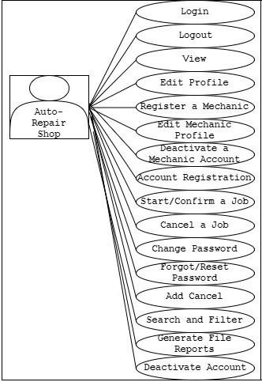

Figure 2. Auto-repair shop Use Case Diagram

1. Account Login
   * Allows the auto-repair shops to login to their accounts and access Mechanic-ko.
2. Account Logout
   * Allows the auto-repair shops to logout from the system.
3. Edit Account Profile
   * Allows the auto-repair shops to edit the shop account details.
4. Register, Edit and Deactivate a Mechanic
   * Allows the auto-repair shops to register, edit and deactivate mechanic accounts in the system affiliated to their shop.
5. Account Registration
   * Allows the owner of auto-repair shop to register an account to the Mechanic-ko application to let its business be shown to the clients/customers.
6. Start/ Confirm a Job
   * Allows the auto-repair shops to start/ confirm a job.
7. Cancel a Job
   * Allows the auto-repair shops to cancel/ decline a job.
8. Change Password
   * Allows the auto-repair shops to change the shop’s account password.
9. Forgot/ Reset Password
   * Allows the auto-repair shops to reset their password whenever they have forgotten it.
10. Add Cancel
    * Allows to add the number of times an auto-repair shop can cancel repair/ job.
11. Search and Filter
    * Allows the auto-repair shop to search and specify a certain record to be viewed in the system.
12. Generate File Reports
    * Allows the auto-repair shop to generate and download files and reports in the system.
13. Deactivate/ Reactivate Account
    * Allows the auto-repair shops to deactivate/ reactivate the shop’s account.

#### Mechanics

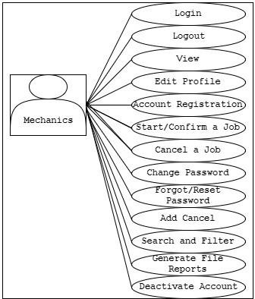

Figure 3. Mechanics Use Case Diagram

1. Account Login
   * Allows the mechanics to login to their accounts and access Mechanic-ko.
2. Account Logout
   * Allows the mechanics to logout from the system.
3. Edit Account Profile
   * Allows the mechanics to edit their account details.
4. Account Registration
   * Allows the mechanics to register an account to the Mechanic-ko application to let its name be shown and hired by the clients/ customers.
5. Start/ Confirm a Job
   * Allows the mechanics to start/ confirm a job.
6. Cancel a Job
   * Allows the mechanics to cancel/ decline a job.
7. Change Password
   * Allows the mechanics to change their account password.
8. Forgot/ Reset Password
   * Allows the mechanics to reset their password whenever they have forgotten it.
9. Add Cancel
   * Allows to add the number of times a mechanic can cancel repair/ job.
10. Search and Filter
    * Allows the mechanics to search and specify a certain record to be viewed in the system.
11. Generate File Reports
    * Allows the mechanics to generate and download files and reports in the system.
12. Deactivate/ Reactivate Account
    * Allows the mechanics to deactivate/ reactivate their account.

#### Motorists

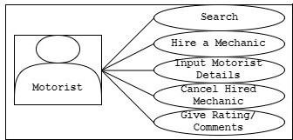

Figure 4. Motorists Use Case Diagram

1. Search
   * Allows the motorists to search for an auto-repair shop or mechanic in the system
2. Hire a Mechanic
   * Allows the motorists to choose and hire a certain mechanic registered in the system.
3. Input Motorist Details
   * Allows the motorists to input their details whenever they hire a mechanic.
4. Cancel Hired Mechanic
   * Allows the motorists to cancel the mechanic that they hired.
5. Give Rating/ Comments
   * Allows the motorists to rate and give comment on the performance of the auto-repair shops and/or mechanics.

#### Admin

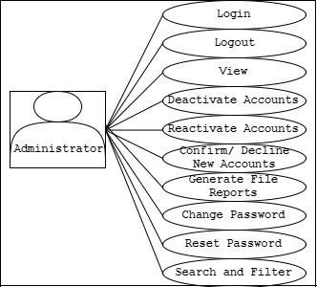

Figure 5. Administrators Use Case Diagram

1. Account Login
   * Allows the admin to login to their accounts and access the Mechanic-ko.
2. Account Logout
   * Allows the admin to logout from the system.
3. Deactivate/ Reactivate Accounts
   * Allows the admin to deactivate/ reactivate accounts of mechanics or auto-repair shops in the system.
4. Confirm/ Decline New Accounts
   * Allows the admin to confirm or decline newly registered accounts of mechanics and auto-repair shops in the system.
5. Generate File Reports
   * Allows the admin to generate and download files and reports in the system.
6. Change Password
   * Allows the admin to change the account password.
7. Reset Password
   * Allows the admin to reset the password whenever they have forgotten it.
8. Search and Filter
   * Allows the admin to search and specify a certain record to be viewed in the system.

#### Design for Mechanic-ko

Mechanic-ko used a 3-Tier Architecture as presented in Figure 6 where the presentation, application and data tiers

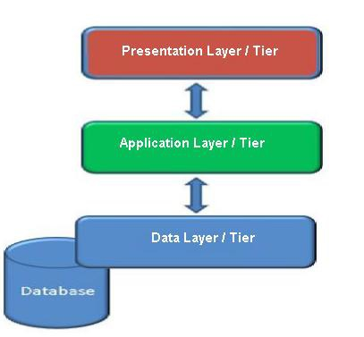are independently maintained, updated and upgraded. This architecture is best fitted for the design and development of the application and it makes the application’s modification and maintainability easier.

Figure 6. 3-Tier Architecture

These tiers have their own functions that contribute to Mechanic-ko’s scalability and performance. A user can access the application through presentation tier and request for data from the data tier and in turn will be given the information they need that have passed through business logic or the application tier. The application tier serves as the user’s interface through any gadget that is able to access the internet and has a browser, such as laptops, computers, smartphones. The application tier is

the Mechanic-ko’s functionalities including its business rules. The data tier are all the informations and datas of Mechanic-ko that are stored and retrieved from the database server. Thus, the developers of Mechanic-ko used this architecture since it is best fitted for the design and development of the application.

The developers have decided to specifically choose the

design and development tools that they knew best for the application. For the development in both the design and functionalities, the programming languages used were PHP, Javascript and JQuery. The interfaces were designed such that they are accessible in any browser. Simple Mail Transfer Protocol (SMTP) was used to send messages through email and File Transfer Protocol (FTP) was used for uploading files and images.

Table 1

*Minimum Requirements for Client Software*

4)

|  |  |
| --- | --- |
| **Browsers** | **Version** |
| Google Chrome 54.0.2840 | |
| Safari 10.0 (MAC OS and Safari | |

5.1.7 (Windows)

|  |  |
| --- | --- |
| Opera | 1.18 |
| Mozilla Firefox 50.0 | |
| Internet Explorer 11 | |

Table 2

*Minimum Requirements for Server Software*

#### Component Version

Apache 2.4.29

PHP 5.4.45

MySQL 5.5.58-cll

Perl 5.10.1

Kernel 2.6.32-042stab120.20

The user interface was designed using HTML5 codes to ensure that the application can adjust to browsers with lower versions. The developers first decided what color scheme to use and then ended up with color blue, orange and gray. For responsiveness, the developers tried if the layout and design fits well on any screen such as adjusting the size of the browser or even viewing it on phones. Moreover, after every build the developers had their meeting to clarify specifications.

A Geolocation API was used in retrieving the location data to show the motorist nearby mechanics and/or auto- repair shop. For the database server, MySQL was used since it is an open source database server that offers different features needed for the application to run smoothly. Beta testing was used to get feedback of improvement before the application will be released. Finally the application is best viewed in Google Chrome Browser with an internet connection to access the application.

Table 3

*Minimum Requirements for Client Hardware*

#### DEVICE COMPONENT DESCRIPTION

Tablets/ Smartphones

Processor 1GHz

RAM 256 MB

Screen size 5.1” or larger

PC/ Laptops Processor 1GHz

RAM 1GB (32-bit) 2GB (64-bit)

Hard Disk 16GB (32-bit)

20GB (64-bit)

Graphics Direct X9 graphics with WDDM 1.0 driver

Table 4

*Minimum Requirements for Server Hardware*

#### Device Component

Processor 2GHz Dual Core

RAM 2GB

Hard Drive 25GB

Drive CD/ DVD Drive or USB port

Display VGA capable of 1024x768 screen resolution

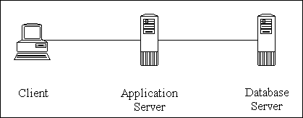As shown in table 3 and 4, The system was developed with PC’s/ Laptops containing specific software and database components that meet the processing needs when developing the system. It can be accessed using different devices that have minimum requirements for operating systems, browsers and network transfer.

Figure 7. Hardware View of Mechanic-ko’s Architecture

Mechanic-ko’s hardware/physical view is composed of the client, application and database server as shown in

Figure 7. The client are the devices and hardwares utilized

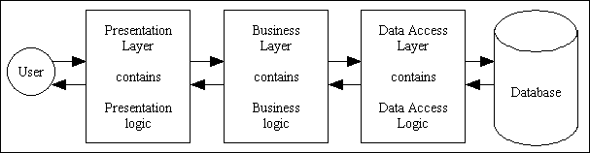by the users in accessing Mechanic-ko. On the other hand, the application server provides computing-intensive operations and services to the residing application and in the database server is where Mechanic-ko’s database is stored. The servers of Mechanic-ko are hosted in Danalex Corporation and [www.godaddy.com](http://www.godaddy.com/) that provides the web server for [www.mechanicko.com.](http://www.mechanicko.com/) The minimum network bandwidth is 360.36 kBps. The computation is presented in appendix L.

Figure 8. Software View of Mechanic-ko’s Architecture Mechanic-ko’s software architecture is composed of the

presentation layer, business layer, data access layer and the database as shown in Figure 8. The presentation layer contains the presentation logic which are the forms and server pages. The business layer contains the business logic which are the business rules and separates the user

interface from data access. The data access layer contains data access logic which are the database drivers. **Features of Mechanic-ko**

These design features identified are based on the user requirements gathered by the developers.

#### Account Management

Mechanic-ko allows users to manage accounts. They can register, login, logout and edit their accounts. The shops can also add, edit and deactivate a certain mechanic account registered in his shop.

#### View, Search and Filter

Users are allowed to view, search and filter the information that they have and use in the system. **Find and Hire Mechanics**

Users, specifically the motorists can hire a specific mechanic, whether freelance or affiliated with a shop. They can see mechanics/ shops available through the working hours they have stated in the system.

#### Cancel Hired Mechanic

Motorists can also cancel the request that they have sent only if the request was not yet confirmed by the mechanic/shop.

#### Report a Mechanic/ Motorist

Motorist can tell whether the mechanic have arrived, or when the repair is done even if the mechanic/shop specified in the system that he have arrived or the repair is done already. On the other hand, mechanics can tell that motorist/ client is not in the specified area/ location. **File Maintenance**

Users can change their password as well as reset their password whenever they forgot it. Mechanic-ko’s admin also has the facility for account management, confirmation and disapproving account registrations.

#### Accept Job/ Cancel Job

The mechanics/ shops are given the option whether to accept or cancel a request/ job given to them by a specific client/ motorist.

#### Deactivation and Reactivation of Account

Users such as mechanics/ shops can deactivate and reactivate their own accounts. While mechanic-ko’s admin can deactivate and reactivate mechanics/ shops accounts. **Notification**

The application sends notifications to their users through email for account registration, password recovery, when their account is confirmed or declined, deactivated or reactivated.

#### Rating and Comments

Whenever a job/ transaction is done, the motorists can give their ratings and comments on the performance of a mechanic.

#### Report Generation

The system generates reports/ pdf files that can be used by the users whenever they want to print or download a certain information in the system.

#### Constraints of the System

The constraints that were identified in Mechanic-ko are the following:

1. Inaccessibility due to loss of internet connection
2. Location feature of the phone is not enabled
3. The development time of Mechanic-Ko is not sufficient for the team due to limited time and deadlines. Also, the mastery of programming language.
4. Systems inability to identify if car has been sold off to a new owner.

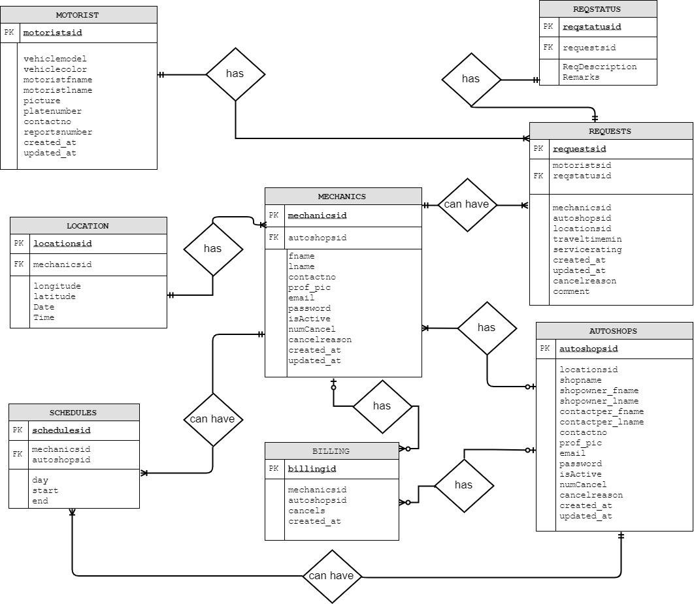

Figure 9: Mechanic-ko’s Database Design Mechanic-ko’s database was designed to have 8 tables

corresponding to its conceptual view as shown in Figure 9, since data needs to be accessed faster through the internet. The developers made a database design where speed

is highly considered rather than the space to be used. Data access is much easier to achieve and data can be retrieved faster. According to Atwood (2008), full blown table normalization is not always the norm, because it increases the difficulty of joining tables, which in turn affects system’s performance. According to Becker (2008), to optimize database access, sometimes requires a not fully normalized tables. Furthermore, it may simplify the updates in the system by having faster access and view of the data. Thus, this conceptual view level supports the external view level to present the data to the end-users as they need. In addition, the database was also designed in such a way that one table can be used to access another table such as the requests table, can be connected to autoshops table through mechanics table.

#### Testing of the Application

Gray box testing of Mechanic-ko was done in order to test whether the validations and functionalities are working well. Beta testing was applied wherein the users are the ones who tested the application to validate new system against user expectations and errors or instances that has been encountered in the use of the application.

In gray box texting, the proponents have used test

cases (Appendix O) and requirements traceability matrix

(Appendix P) in order to trace the different possibilities, cases, scenarios and validations in the system. Several testing iterations were made wherein after every testing, an increment is created.

In the beta testing phase, the proponents gave out

survey questionnaires for the users who used the application mechanic-ko as shown on Appendix J. The test results were used as a basis on improving the usability of the application, in which the users who tested the application commented on how hard to use it for the first time. The usability of the application was improved by releasing a video tutorial on how to use the application. Another result that came out from the beta testing is the matter on security wherein some users do not feel secure when using the application. The issue on security was partially solved by implementing access levels in the application wherein it restricts the functions a user can do depending on usertype and assuring the users that the mechanics and auto-repair shops registered in the application are legitimate. The issue on reliability also emerged in the beta testing phase. Some users who tested the application were unable to view the google map which is responsible for finding the location of the user and the mechanics, thus removing the reliable feature of the

application in using real-time availability. The issue on reliability was solved by securing the application with SSL certificate, this certificate activates the https protocol and allows secure connections from a web browser to a server. Through the SSL, the system can determine the current location of the user and the availability of the auto shops and mechanics in real-time.

Through the series of tests done in ensuring the quality of the application, the proponents were able to improve the performance of the application Mechanic-ko.

#### CHAPTER 5 CONCLUSIONS AND RECOMMENDATIONS

This chapter discusses the conclusions and recommendations of the application.

#### Conclusion

Having a car breakdown in the middle of the road and finding a mechanic is difficult for motorists. Mechanic-Ko is a mobile-web application that addresses the major aspects in finding nearby mechanic for the motorist. The developers of the application, Mechanic-Ko, concludes that in developing an emergency motorist assistance web- application, the team must understand the problems encountered by the motorists. This is based on the gathered information from the motorists and mechanics during interviews. The application must consume a minimal data usage to reduce internet-connection related costs.

The mobile web application must follow the standards in creating and designing both web based application and mobile based applications. The ease of use of the application and the small data usage of the application will be prioritized since the users are using data connection. Overall, the developers ensured that Mechanic- Ko will benefit both the motorists and mechanics by making the system as a bridge between motorists who are in need of

assistance and mechanics or auto repair shops that are providing services for car breakdowns. Similarly, the mechanic-ko acts as a way to assist motorist in case of emergency, since they can just hire a mechanic with just a few clicks on the browser and operates 24/7. The users are also secured since the mechanics and auto-repair shops are legitimate and must agreed on the terms and conditions before they can even register.

Also, the data that were gathered were used in order to come up with the requirements needed in the development of Mechanic-ko. Specifically, the identification of target users as well as their needs. Aside from that, Mechanic-ko addressed the problem that was identified from the start of the development which is the car breakdowns be it in the middle of the road or anywhere. It provides specific features that will help the society and that will help motorists, mechanics and shops as the users of the system. These features conforms to the standards of w3c such as reliability, usability and security.

Thus, through the requirements that were gathered, a design of the system was conceptualized and proposed to be used in the design and development of the system.

Several assumptions and constraints were identified wherein these constraints are the limitations or edge to which the application mechanic-ko will only work.

In developing Mechanic-ko, the conceptual view of the database was based on the circumstances depending on the time constraints, the normalization of the database comes with new tables that will have different indexes. Choosing speed over size was made since data access can be obtained smoothly and also will decrease the processing time of the system.

Furthermore, the system was built with consideration of the different requirements and design made. And it was deployed on the web and tested by the users wherein this system, if used appropriately, it may help motorists, mechanics and shops in connecting and transacting with other easier. In such a way, motorist can find mechanics or shops to hire, aside from that, mechanics and shops can use the application as a way for having clients, and advertising their company as well. In the same way, by using mechanic-ko auto-repair shops and mechanics can increase the number of clients they have in a day since a lot of people can view and hire them online. Moreover, the mechanic-ko is best viewed using google chrome browser. Lastly, mechanic-ko had gone through a series of tests

which ensured that the initial product handed over to the testers was functioning well. Through all of this by using the mechanic-ko, the developers concluded that this is a mobile web application which provides nearby mechanics/and or auto-repair shops wherever a specific motorist is. It also doesn’t let the motorist wait since it is a real time application that tells whenever a mechanic have confirmed or cancelled the hiring. Finally, the motorist and mechanic will know who they will meet because they need to upload a picture of themselves. So, a mechanic-ko is an emergency motorist assistance operating with its desired purpose.

#### Recommendations

The researchers recommend the following for future researchers:

* Since Mechanic-Ko is a mobile web application,

the researchers recommend that the application be developed as a mobile application that can be available in google play store.

* Expand the scope of the mobile web application, Mechanic-Ko, e.g. blacklisting of users whenever reported, list and choices of the auto repair shops or mechanics for the motorists, increase the range of the area that the application can

accommodate, billing details for the services, SMS notification, and an online messenger for communication purposes of both mechanic and motorists.

* To establish more secured transactions the

motorists should capture a photo of his and is attached to the hiring mechanic process.

* The researchers recommend further testing of the system such as the stress testing and SQL injection testing. Since stress testing would enable future developers to see the limit and the effectiveness of the system against unfavorable conditions and different scenarios and SQL injection testing in order to secure the system of different security exploit attackers.